INFO 5717

GROUP 4 – TERM PROJECT

ONLINE FORUMS & COMMUNITIES FOR

DATA SCIENCES

By

SAISPHURTHI THUMMALA

ALEKHYA LINGALA

LAKSHMI DEEPA SUNKARA

SAISHIVANI BODDIREDDY

**1.1 Objectives and User Requirements:**

**Description**

In this project mainly, the Forums and Online Communities on Data Science and its related fields were listed. A website named “*Forums and Online Communities on Data Sciences*” was created in order to store all these list of Forums and Online Communities as records. We created a database that holds records of Forums and Online Communities on Data Sciences. Each Forum and Online Communities are present in Online and all those Forums and Online Communities are real and exist in the internet. The website will allow the users to access the data present in the database and also at the same time they will allow only the authorized users to entry new records into the database through the online data entry form from our website. Our website also consists of some of the queries results where users can be able to access them and can get to know more about the database.

**Objectives**

Objectives of this system is to create a web system where users can search and insert records into the existing database without any intervention from database. The system will capture and search nearly all the Forums and Online Communities. This system will help the users to understand by giving information about data sciences are their related topics through different Forums and Online Communities and also the users can get to know the opinion and perspective of other users.

**User Requirements**

Our system will web crawl some of the online forums and communities and capture their URLs on data sciences and their related topics. The user requirements are that each should at least capture 10 distinct records for the subject respectively. The other user requirements are to design a system with which we can search information in the data base and external users can add records into database and also can view some of the database results.

**1.2 Business rules:**

* A User can participate in many types of forums or online communities on Data Sciences.
* A single type of forum or online communities can have many users.
* A single type of forum or online communities can manage many posts done by various users.
* A single user can create many posts on different forums and on online communities on Data Sciences.

**1.3 Data Dictionary:**

|  |  |  |  |  |  |  |  |
| --- | --- | --- | --- | --- | --- | --- | --- |
| **TABLE NAME** | **ATTRIBUTE NAME** | **CONTENTS** | **TYPE** | **FORMAT** | **NULL- YES/NO** | **PK OR FK** | **FK REFERENCED TABLE** |
| ADMIN | ID | Unique admin Identification ID | INT(11) | XXXXXXX | NO | PK |  |
| Username | Name of the admin | VARCHAR (100) | XXXXXXX | NO | - |  |
| Password | Password of the admin | VARCHAR (100) | XXXXXXX | NO | - |  |
| TYPE | TYPE_ID | Unique Type Identification ID | INT(10) | XXXXXXX | NO | PK |  |
| USE_ID | Unique User Identification ID | INT(10) | XXXXXXX | NO | FK | USE_DETAILS |
| POST_ID | Unique Post Identification ID | INT(10) | XXXXXXX | NO | FK | USE_POSTS |
| USE_NAME | Name of the forum or online community | VARCHAR (225) | XXXXXXX | NO | - |  |
| TYPE_NAME | Specification of forum or online community | VARCHAR (225) | XXXXXXX | NO | - |  |
| TYPE_DESCRIPTION | Description of forum or online community | VARCHAR (225) | XXXXXXX | NO | - |  |
| TYPE_URL | Url link of forum or online community | VARCHAR (225) | XXXXXXX | NO | - |  |
| [USE_DETAILS](http://iia02.ci.unt.edu/phpmyadmin/sql.php?server=1&db=5717G4&table=USE_DETAILS&pos=0&token=dab828c4db8ea3ba185d4d2c18db2afe) | USE_ID | Unique User Identification ID | INT(10) | XXXXXXX | NO | PK |  |
| TYPE_ID | Unique Type Identification ID | INT(10) | XXXXXXX | NO | FK | TYPE |
| POST_ID | Unique Post Identification ID | INT(10) | XXXXXXX | NO | FK | USE_POSTS |
| USE_NAME | Name of the user | VARCHAR (225) | XXXXXXX | NO | - |  |
| USE_EMAIL | Email address of the user | VARCHAR (225) | XXXXXXX | NO | - |  |
| USE_REPLY | Reply of the user | VARCHAR (225) | XXXXXXX | NO | - |  |
| [USE_POSTS](http://iia02.ci.unt.edu/phpmyadmin/sql.php?server=1&db=5717G4&table=USE_POSTS&pos=0&token=dab828c4db8ea3ba185d4d2c18db2afe) | POST_ID | Unique Post Identification ID | INT(10) | XXXXXXX | NO | PK |  |
| TYPE_ID | Unique Type Identification ID | INT(10) | XXXXXXX | NO | FK | TYPE |
| USE_ID | Unique User Identification ID | INT(10) | XXXXXXX | NO | FK | USE_DETAILS |
| USE_POSTINGS | Number of posts made by the user | INT(10) | XXXXXXX | NO |  |  |
| No_of_LIKES | Number of likes for the user’s posts | INT(10) | XXXXXXX | NO |  |  |
| No_of_COMMENTS | Number of comments for the user’s posts | INT(10) | XXXXXXX | NO |  |  |
| TOTAL_VIEWS | Number of comments for the user’s posts | INT(10) | XXXXXXX | NO |  |  |
| FIIRSTPOST_DATE | Date of the first post | DATE | XXXXXXX | NO |  |  |

**1.4 Entity-Relationship Diagram:**

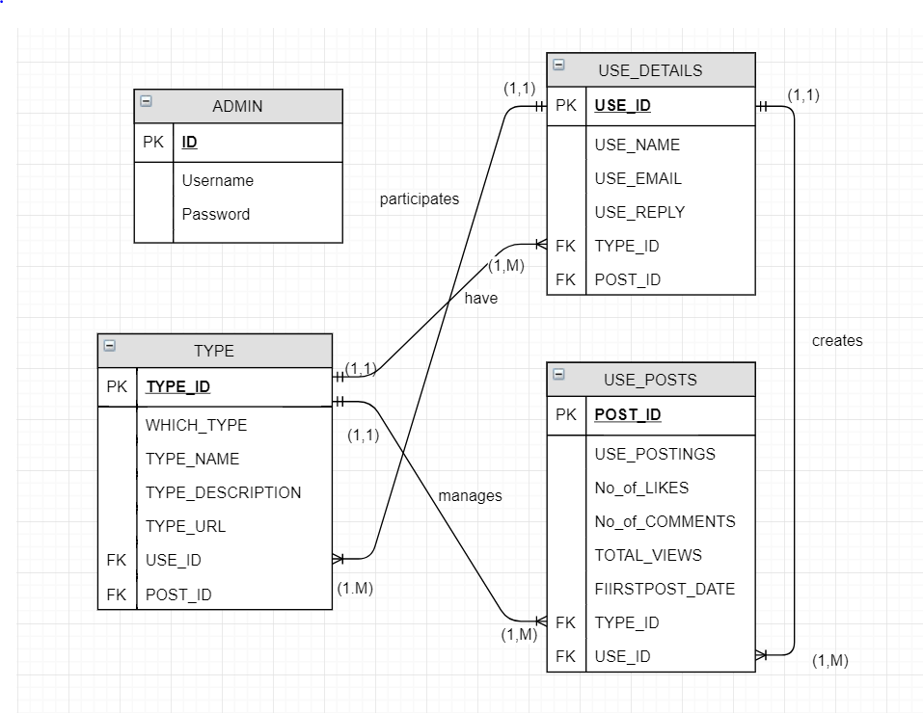

**1.5 SQL SCRIPTS for creating tables:**

1. ADMIN Table

CREATE TABLE ADMIN (

ID INT (11) NOT NULL UNIQUE,

Username VARCHAR (100) NOT NULL,

Password VARCHAR (100) NOT NULL,

);

1. TYPE Table

CREATE TABLE TYPE (

TYPE_ID INT (10) NOT NULL UNIQUE,

USE_ID INT (10) NOT NULL UNIQUE,

POST_ID INT (10) NOT NULL UNIQUE,

WHICH_TYPE VARCHAR (225) NOT NULL,

TYPE_NAME VARCHAR (225) NOT NULL,

TYPE_DESCRIPTION VARCHAR (225) NOT NULL,

TYPE_URL VARCHAR (225) NOT NULL,

PRIMARY KEY (TYPE_ID),

FOREIGN KEY (USE_ID) REFERENCES USE_DETAILS (USE_ID),

FOREIGN KEY (POST_ID) REFERENCES USE_POSTS (POST_ID)

);

1. USE_DETAILS Table

CREATE TABLE USE_DETAILS (

USE_ID INT (10) NOT NULL UNIQUE,

TYPE_ID INT (10) NOT NULL UNIQUE,

POST_ID INT (10) NOT NULL UNIQUE,

USE_NAME VARCHAR (225) NOT NULL,

USE_EMAIL VARCHAR (225) NOT NULL,

USE_REPLY VARCHAR (225) NOT NULL,

PRIMARY KEY (USE_ID),

FOREIGN KEY (TYPE_ID) REFERENCES TYPE (TYPE_ID),

FOREIGN KEY (POST_ID) REFERENCES USE_POSTS (POST_ID)

);

1. USE_POSTS Table

CREATE TABLE USE_POSTS (

POST_ID INT (10) NOT NULL UNIQUE,

TYPE_ID INT (10) NOT NULL UNIQUE,

USE_ID INT (10) NOT NULL UNIQUE,

USE_POST INT (10) NOT NULL UNIQUE,

No_of_LIKES INT (10) NOT NULL UNIQUE,

No_of_COMMENTS INT (10) NOT NULL UNIQUE,

TOTAL_VIEWS INT (10) NOT NULL UNIQUE,

FIIRSTPOST_DATE DATE NOT NULL,

PRIMARY KEY (POST_ID),

FOREIGN KEY (TYPE_ID) REFERENCES TYPE (TYPE_ID),

FOREIGN KEY (USE_ID) REFERENCES USE_DETAILS (USE_ID)

);

**1.6 BREIF DESCRIPTION OF WEBSITE:**

**Entire Website Description:**

This Website mainly discusses about the Forums and Online Communities on Data Sciences. In this website an authorized user can be able to perform search over the database to know the record details and also through their login credentials they can be able to login and enter new records into the database by filling out the details in the Entry Form page. Users who are new to this website can be able view the basic information about the database through the Search Page, in the Search Page predefined query results were given so that user can easily get to know information about the database records. Further they can sign up for our website and can become an authorized user. Our group members (Group 4) have created a database that holds records of Forums and Online Communities on Data Sciences. Each Forum and Online Communities listed in the database were present online and all those Forums and Online Communities are real and exist in the internet. Finally, through the Contact Us Page, user can get connected with our Group4.

**Welcome Page:**

It is the home page of the website which has links to rest all other pages. It gives a brief description to the users on how the website works and what is done in the project. It will also list all the Team members names.

<http://iia02.ci.unt.edu/5717/group4/Welcome.html>

**Search Page:**

This page provides users with various search options in the form of a dropdown list. When user selects any of these options, the search page will redirect to the respective PHP page and displays a detailed and statistical analysis of the selected records in a table format which are retrieved from the 5717G4 database.

<http://iia02.ci.unt.edu/5717/group4/Search.html>

**SignUp Page:**

This page provides the sign in option for the new user in order to become authorized users. As soon as the user enter their details and click on the SignUp button, the page gets redirected to the SignUp.php page and this page will store all their login credentials in the 5717database and will allow them to become authorized users.

<http://iia02.ci.unt.edu/5717/group4/Sign.html>

**Login Page:**

This user login page will allow only the authorized users to login. By logging in, these authorized users will be redirected to the EntryForm. Html page.

<http://iia02.ci.unt.edu/5717/group4/Userlogin.html>

**EntryForm Page:**

The page will allow only the authorized users to add new data records into the tables (TYPE Table, USE_DETAILS, USE_POSTS) present in the database. There will be an entry form in this page, as soon as the user enter the data and click on submit button, the data will get stored into the database.

<http://iia02.ci.unt.edu/5717/group4/EntryFormDetails.html>

**ContactUs Page:**

In this page details of each team member are mentioned in this web page. If users have any doubts regarding the information present on our website, they can contact us through any of the Email Id's mention in the web page.

<http://iia02.ci.unt.edu/5717/group4/Contact.html>

**SITE MAP:**

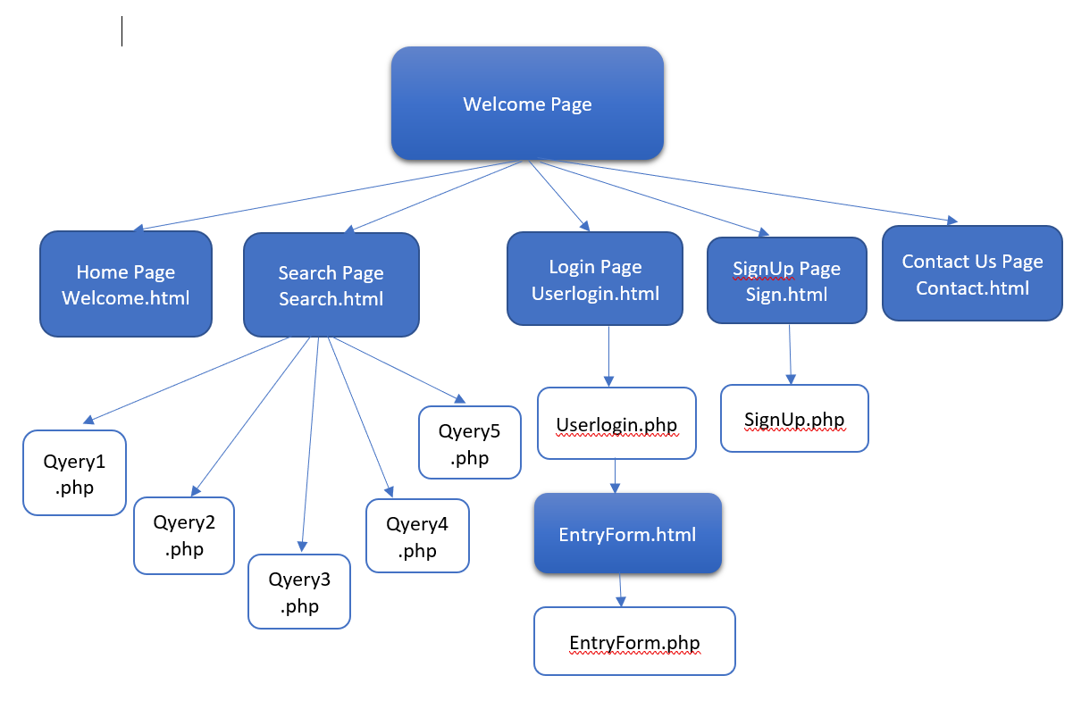

**1.7 Usability Considerations**

**1.8 URL of Website:**

Main URL of website: <http://iia02.ci.unt.edu/5717/group4/Welcome.html>

**Usernames and Passwords for the Login Page**

1. Username: 5717User1

Password: UserAccess1

1. Username: 5717User2

Password: UserAccess2

1. Username: 5717User3

Password: UserAccess3

1. Username: 5717User4

Password: UserAccess4

1. Username: 5717User5

Password: UserAccess5